**🦸‍♂️ HERO SECTION (BEST PRACTICE GUIDE)**

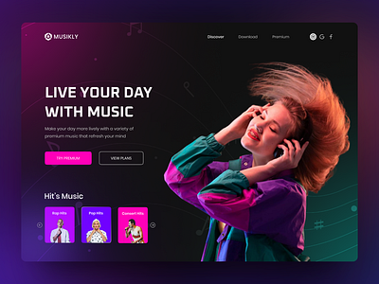



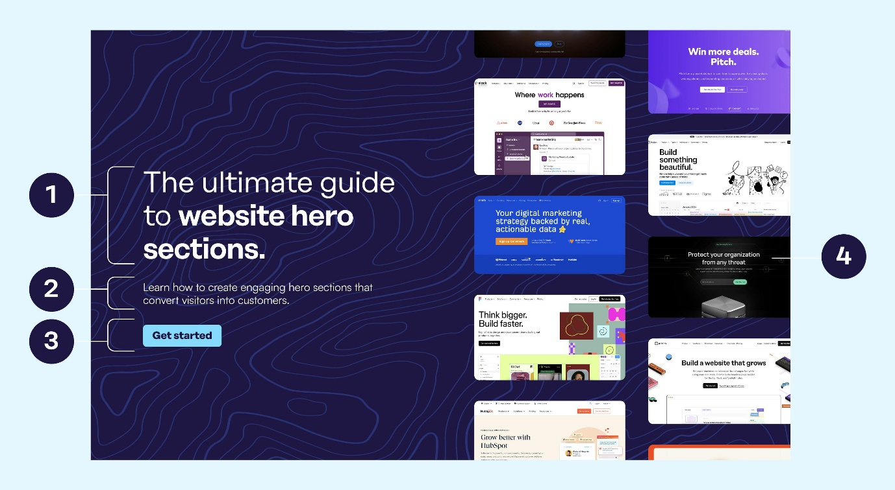

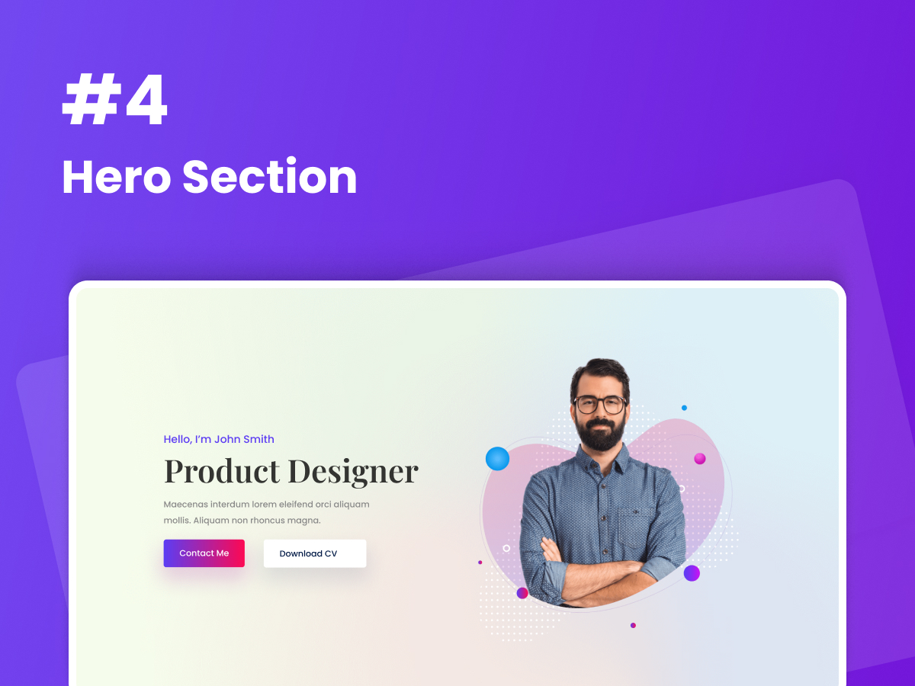

**🧱 2. HERO SECTION (WHAT & WHY)**

👉 The **Hero Section** is the **first screen users see**  
👉 You have **3–5 seconds** to grab attention  
👉 It answers one question instantly:

**“What is this website and why should I care?”**

**🧩 HERO SECTION STRUCTURE**

Hero Section

├── Headline (Main Message)

├── Subheading (Support Message)

├── CTA Buttons

└── Visual (Image / Slider / Video)

**🅰️ Headline (Main Message)**

**✔️ Purpose**

* Strong, clear, benefit-driven
* NOT long
* NOT technical jargon

**✔️ Best Practice**

* 6–12 words
* One clear value

**✅ Good Examples**

Build Skills That Get You Hired

Design. Develop. Deploy Faster.

Learn Industry-Ready Tech Skills

📌 **Analogy**  
Headline = **movie title**, not the full story.

**🅱️ Subheading (Supporting Message)**

**✔️ Purpose**

* Explain the headline in 1 line
* Add clarity & trust

**✅ Good Example**

Learn web development, VLSI, and software skills with real projects and expert guidance.

📌 Think of it as **movie trailer dialogue**.

**🅲 Call-To-Action (CTA) Buttons**

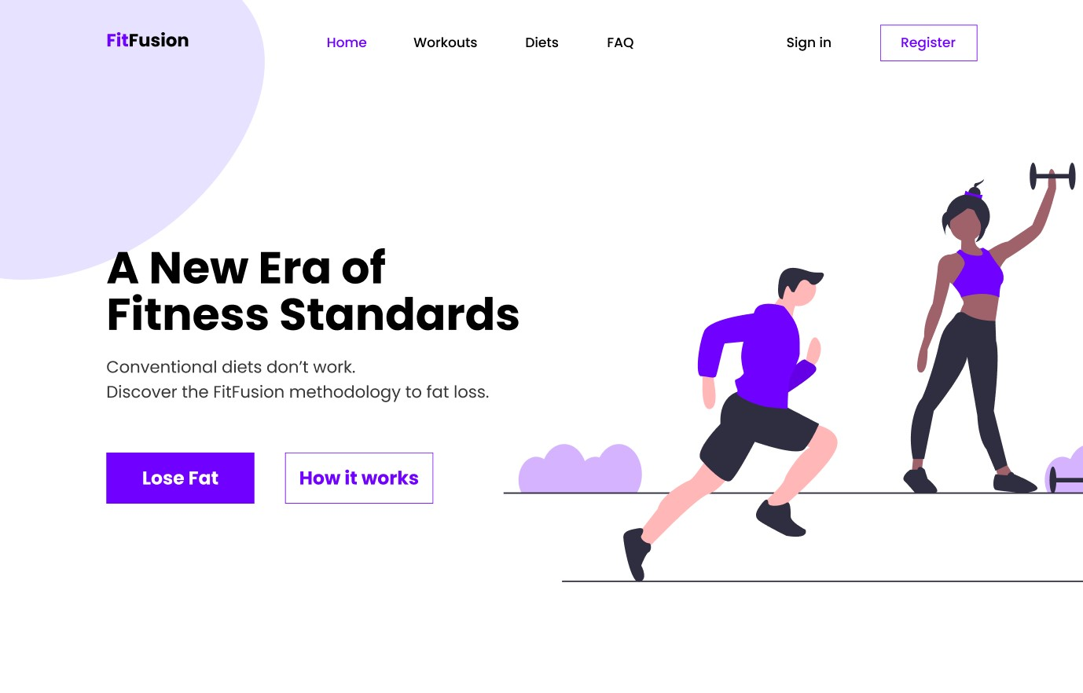

**✔️ Best CTA Structure**

* **Primary CTA** (filled button)
* **Secondary CTA** (outline button)

**✅ Examples**

| **Primary CTA** | **Secondary CTA** |
| --- | --- |
| Get Started | View Courses |
| Enroll Now | Watch Demo |
| Join Free | Learn More |

📌 **Rule**

One action should be more important than the other.

**🅳 Hero Visual (THIS IS IMPORTANT)**

**❓ Image vs Slider vs Video — Which is BEST?**

Let’s be honest 👇

**🥇 BEST OVERALL: Hero Image (or Illustration) ✅**

✔ Fast loading  
✔ SEO-friendly  
✔ Works on all devices  
✔ Easy to maintain

**Use when:**

* Portfolio
* EdTech
* Corporate
* Startup websites

📌 **Recommendation:**  
👉 **1 strong image + text = best conversion**

**🥈 SLIDER (Use Carefully ⚠️)**

✔ Shows multiple messages  
❌ Users ignore slides after first  
❌ Slower UX

**Use only if:**

* Marketing banners
* E-commerce offers

📌 **Interview Answer**

“Sliders often reduce clarity and engagement if overused.”

**🥉 VIDEO BACKGROUND (Premium but risky)**

✔ High impact  
❌ Heavy loading  
❌ Bad on slow networks  
❌ SEO issues

**Use only if:**

* Brand storytelling
* Landing pages
* Short looping video (5–8s)

📌 If used → **mute + loop + fallback image**

**🏆 FINAL VERDICT (BEST ONE)**

**✅ BEST HERO SECTION =**

Text Content (Left)

+ Strong Image / Illustration (Right)

+ Clear CTA Buttons

This is what **Apple, Google, Udemy-style sites** follow.

**🧠 IDEAL HERO LAYOUT (DESKTOP)**

| Headline + CTA | Hero Image |

**📱 MOBILE**

Headline

Subheading

CTA Buttons

Hero Image